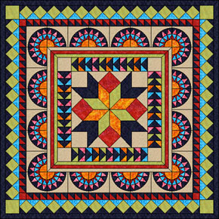
2020 Gentry
Chamber of Commerce
Quilt Show

Hello Quilters!!!

The date for the Gentry Chamber of Commerce Quilt Show has been set for January 17 - 24, 2020. We are excited and looking forward to another great show this year. This is our 12th Annual Chamber of Commerce Quilt Show and we are being sponsored by McKee Foods again this year.

I have application forms available at the Gentry Quilts, Gentry Chamber of Commerce office and downloadable on the Gentry Chamber of Commerce website www.gentrychamber.com.
I will include an application with this letter and you are welcome to copy it if you would like to enter more than one quilt.

The quilt show will be held at the Gentry Public Library in the McKee Community Room. I will be there to take the entered quilts on January 15th from 1-4 pm. If you plan to enter a quilt you must fill out an application and send it to Gentry Chamber of Commerce, P.O. Box 642, Gentry, AR, 72734 before January 14th. Because of limited space, we must limit quilt entries to 2 per person. If you have others you would like to enter make a note on the application and if space is available I will call you. Quilts will be ready to pick up on January 24th, between 2-4pm.

If you have questions just call me, Janie Parks at 479-936-1498 or 479-736-2358.

